10 DIY Photo Filters on the Cheap
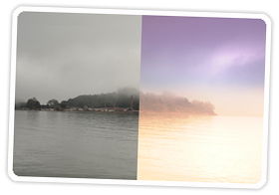
Extra photos for bloggers: 1, 2, 3
Back before Snapseed and Instagram, photographers used lens filters to add snazzy effects to their snapshots.
But filters can cost you a pretty penny, and you’re quite happy keeping your pennies, thankyouverymuch.
Well, we’ve got you covered because we’ve rounded up 10 DIY photo filters that won’t cost you.
In fact, most of these things are probably just lying around the house!
So follow along with our roundup as we accentuate the analogue and re-imagine the digital.

Why it’s cool:
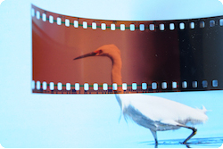
Filters work with all types of cameras so you can use them for phoneography, film, or digital!
DIY filters can add an endless variety of effects to your photos without ever having to use complicated software or buy expensive gear.
To illustrate this, all of our tutorial images were created without the aid of digital editing.
Just light, filter, and a little magic.

#1 The Film Negative Split Filter:
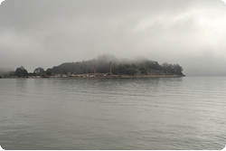
You thought your unused bits of film negatives were just taking up space, but lo and behold they have a purpose after all!
For this shot the end of a color film negative was placed in front of the lens.
We used the part where it makes the transition from light sensitive auburn to the muddy dark bit at the end.
The result is a dreamy colored fantasy world where fog becomes grape colored skies and murky water becomes a golden harvest.
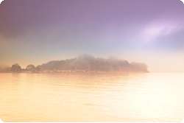
While the film filter adds an awesome effect to your photo it will also block some of the incoming light. Make sure adjust your settings to compensate.
Also, try using just the lighter or darker side of your film strip for a uniform nutty warmth or a deep chocolatey hue.
Mmm, now we’re getting hungry.

#2 The Magnifying Glass Macro:
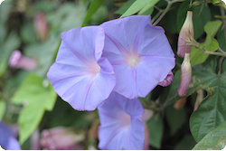
There are a few ways to make a DIY macro lens, but try playing with a magnifying glass!
Take this opportunity to zoom in on ambling insects or scare the pants off some dew drops with your new super close-up skills.
The one tricky bit can be finding focus.
We found setting the focus ahead of time, holding the magnifying glass against the lens, and moving the camera in and out to be most effective.
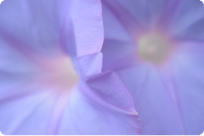
Honestly, the level of detail and clarity you can achieve by simply placing a magnifying glass in front of your lens and getting up close is quite surprising.
So go ahead, give your goldfish the portrait that it has always deserved.

#3 The Poker Hat Green Filter:
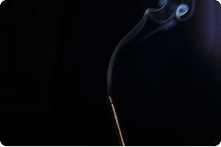
Green filters are a fun way to make simple scenes into Martian green mysteries or change the contrast of your black and white shots.
We tried a few different items here: a Sprite bottle, a plastic shopping bag, but ultimately we settled on a green poker hat (which doubles as quite the photo fashion accessory).
To accomplish this shot we allowed a crack of light to illuminate the smoke from an incense stick in an otherwise dark room.
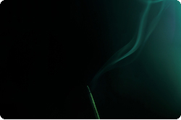
The green filter does an awesome job of coloring in the smoky trail and adds an interesting gradient to the light filtering in from the window.
A nice bonus with the poker hat is its large size and flexibility which allows it to be used with pretty much any lens.

#4 The Bokeh Shape Bonanza:
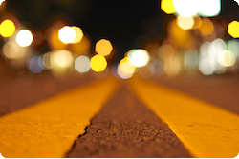
Bokeh is a fancy word for the blurry round light blobs that show up in the background of shallow depth of field photos.
This shot was created using the The Bokeh Kit from Photojojo, which allows you to trade out regular old circular bokeh for your own unique shapes!
Our experiments showed the kit worked best at
night when you combine a close subject with far away lights to create a background twinklefest.
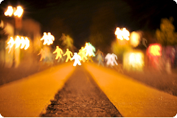
If you don’t want to shill out the bucks for the kit you can also try cutting shapes in cardboard or thin plastic.
Alright Mr. Nightowl, brew up a pot of coffee, grab your favorite low light lens, and hit the town to find shimmering bokeh shapes as far as the eye can see!

#5 Jersey Patterns:
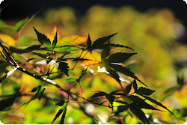
Remember those yellow and red practice jerseys from PE class?
Well turns out these old team makers can create an optically interesting surprise.
To get the effect, simply take a criss-cross fabric jersey and pull it tightly over your lens.
You will want to aim at a close subject with a blurry background to witness the bug vision pattern your jersey overlays onto out of focus areas.
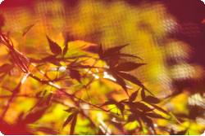
The fabric will also color in dark shadows, and create a dreamy haze similar to the effect of using expired film.
You can enjoy these colorful kaleidoscopic textures night or day, but avoid direct sunshine on your lens as it will disrupt the effect.
Three cheers for dragonfly vision!

#6 The Colored Glass Macro Marvel:
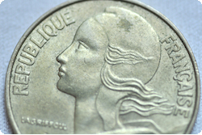
While not a filter per se, this is an easy way of dipping your macro shots in a tasty cup of color!
For this image, we simply put a coin into a colored wine glass, placed the glass in direct sunshine, and snapped a pic with our macro lens.
The only tricky bit was trying to look through our digital SLR’s viewfinder with the camera pointed straight down.
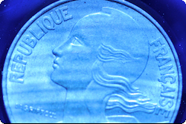
We found using the camera’s rear LCD much easier for composing the shot and locating spot on focus.
Try using different colored wine glasses or change the lighting for fun variation.
Now that you’ve got the basics go forth and explore great macronaught!

#7 The Eyeglass Wormhole:
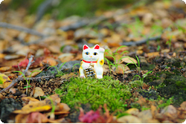
Alright four-eyes of the world, it’s your time to shine!
Take those glasses off your face and put them in front of the camera.
Gaze with wonder at the tear in the fabric of the universe you have created.
Experiment by moving your glasses closer or farther from your subject and camera to vary the amount of blur, just remember to refocus!
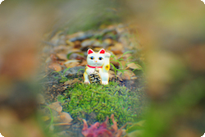
Try testing your luck with reading glasses and
a smartphone.
Tilt the frames up or down and watch as the image does the timewarp, stretching and distorting like you were moving at incredible speed.
Where will this photographic wormhole take you? Let us know when you get there.

#8 The Pantyhose Portrait Softener:
For that dreamy 80’s glamour shot feeling, look no further than your sock drawer!
An old pair of sheer pantyhose, cut and pulled tight over your lens, can do wonders to soften and add hazy mystery to your portraits.
The effect can be quite strong, but we found putting a run in the stocking material helps to allow a little more light on your subject.
Also, like the filter in #5 it’s best to use this setup in the shade as direct sunlight on your lens will cause the image to be overly washed out.
We love taking portraits and we took this filter everywhere as it rolls up and fits easily into a pocket or camera bag.
Expand your horizons by experimenting with colored fabrics for different scenes, skin tones, and lighting situations.

#9 The Water Bottle Pinhole Camera:
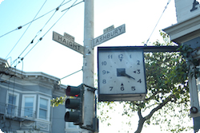
Travel back in time with this awesome pinhole camera effect!
All you will need for this filter is a plastic water bottle and a pair of scissors.
Cut off the top third of your water bottle and also remove the top part with the cap. Your water bottle should look like this.
Now place it over your lens and point it at your subject.
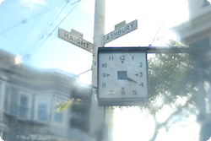
Playing with your aperture can create interesting variation: a small aperture produces a rippley circular halo, while a wider aperture forms a center accentuating psychedelic haze.
You can also aim your water bottle around the frame like a tilt shift lens to accentuate different parts of your pic.
Welcome to a world of blurry low def awesomeness sir. Here, have a monocle.

#10 The Sunglasses Gradient:
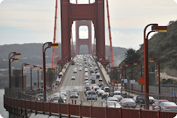
Ah, another beautiful day in nature, perfect time to snap a pic!
But certain high contrast scenes, especially sunrise and sunset, can be difficult for your camera to capture creating overwhite skies and underexposed land.
Fortunately, mankind has devised a solution for protecting our eyes from the sun’s harsh rays in the form of sunglasses.
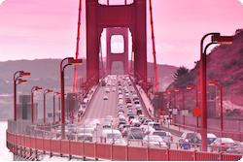
We placed a pair of reddish tinted sunglasses over our lens for this shot.
The sunglasses had a darker gradient at the top fading to lighter at the bottom which helped to bring the all too bright sky under control and gave the underexposed bridge bits the light that they rightfully deserve.
Pop a pair of sunglasses over your lens and fear sunset photography no more!

