How to create 6 month exposures.
How to make install and scan video here
For pinhole and Solargraph workshops visit my workshops page.
Please have a look at Tarja Trygg's www.solargraphy.com for more examples.
Much of pinhole photography relates to the use of time and being creative with the light from the sun, similar wonders to that found in astronomy. A 6-month exposure will enable you to image the arc of the sun as it rises or sinks throughout 6 months of the year. As well as this you will get some foreground detail and a camera to look at with awe as a small hole etches its 6-month exposure from your window ledge, garden shed, lamp post, tree etc.
Being able to capture a period of time far beyond our own vision is incredible enough, but even more amazing is how simple it is to do. The final camera gives an extreme wide angle of view of 160 degrees.
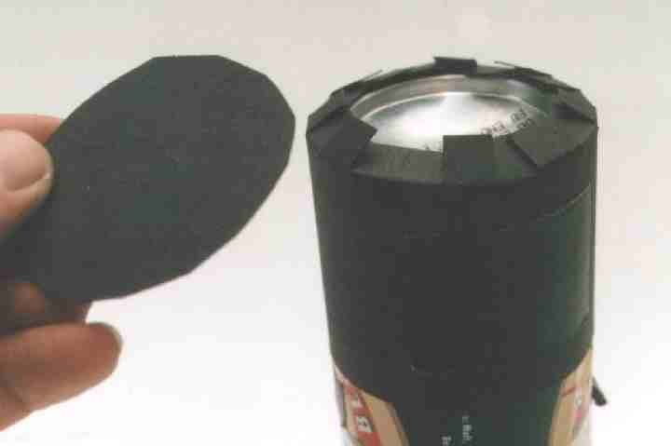  Making a light proof lid out of card.  (This is covered with black gaffer tape after the photographic paper is inserted) | What you will need:  An aluminium can  (or 35mm Film 'pot')  Black Card  A Pin  Black Gaffer Tape  Cable ties  Some 5x7 Semi Matt Black and White Photographic paper  (easily availiable online for around £5-00 for 25 sheets)  6 months.  Optional:  Reflective jacket  Builders Hard hat  Stepladder | 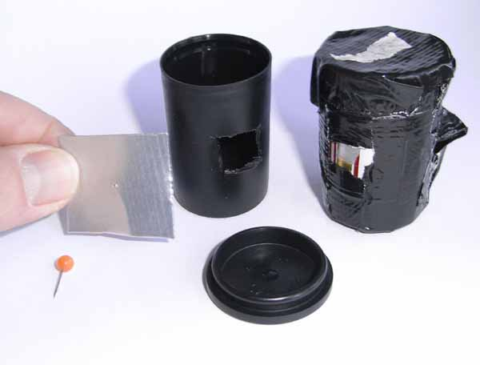  35mm Film Pot camera.  Notice hole cut in plastic tub and final taped up version. A pencil has been taped on the back to point it upwards to catch the height of the summer sun.
Assembly
Drink Can
Remove the top off an ALUMINIUM can with a good can opener. (Avoid steel as it leaves a dangerous sharp edge). Tall beer cans are best, as not only do they take untrimmed 5x7 paper, but they also contain beer!
Cut out, using thin black card, a circle 6 cm in diameter and a strip 25cm x 7cm with notches cut along one edge. Use some gaffer tape to assemble a light proof cap on the end of a can.
Push in and remove a pin half way up the side of the can and move it around to make the hole about 2 mm in diameter (don't worry too much!)
Cover the hole with an insulation tape 'shutter', then place on the light-tight cap.
Film Pot
These contain 35mm film and have the advantage of being far smaller and less conspicuous than the Can cameras.
To keep maximum quality however, you will need to make a smaller hole of around half a mm. The disadvantage is they don't hold beer!
Use the pots with black lids.
Using a craft knife cut a small 1cm square from the side of the plastic pot.
Make a pinhole in a 2cm square piece of aluminium from a drink can and push the end of a pin into the aluminium to make a ½ mm sized pinhole (but don't worry too much!).
Use black insulation tape to tape the pinhole onto the outside of the pot then cover the hole with an insulation tape 'shutter'.
Loading photographic paper
In red light (a rear bike light in the bedroom with the light off will be fine), insert a 5x7 sheet of semi matt photographic paper curled round the inside of the can emulsion inwards, (use a 70mm x 45mm piece for the film pot).
Make sure the paper doesn't cover the hole (there should be a 1 cm gap) then replace the cap.
Cover the lid with loads of gaffer tape (to keep out the rain, snow, sleet, lightening, mice etc)
Taking your photo
Find a position pointing towards the Sun. South in the Northern Hemisphere and North in the Southern Hemisphere (I presume!). Google Earth will show you South.
A window ledge is ok but choose a nice view if possible and make sure it is well out of reach of enthusiastic street cleaners! It's going to be exposing for some time, day and night.
Chose a date to start the exposure. This winter solstice (2009) is December 21st.
Fix the camera sturdily in position. It needs to cope with all that 6 months of natures elements can throw at it. I find a healthy mix of gaffer tape and cable ties works quite well. Gluing a pencil onto the side will help to keep the camera steady if fixed to a circular object such as a lamp post. Glueing one horizontally on the back will tilt the camera upwards slightly enabling the capture the height of the Summer sun.
Peel the shutter (sticker) off, go inside and write on your calendar when you will stop the exposure.
Have a look at it from time to time thinking things like, "I wonder what is going on in there".
After 6 months place the tape shutter onto the hole and bring the camera back home after its long ordeal. (OK, its not exactly the Shackleton expedition I know but by now it probably needs a rest!)
The Clever bit.
- Switch off the light in your computer room.
- Set the scanner on a highish resolution (500dpi is good for 5x7, 900 ish for the film pot)
- Take the photo paper out of the can camera and ,,,,,,without developing it (Told you it was clever!), place it onto the scanner with a book on top to hold it flat and press scan.
- Save the negative image on your computer.
- After scanning, place the undeveloped print into a box entitled 'scanned paper negs'.
- Open up Photoshop or PaintNet. (Paintnet is entirely free and just as capable of what is required). http://www.getpaint.net/download.html).
- Image > Inverse > Flip horizontal and play around with the contrast and brightness.
- Show off to your mate in the pub after he has shown you his photos of Teneriffe.

THE 35mm PINHOLE CAMERA

Many of our first attempts at pinholing involve replacing the lens of an SLR with a pinhole. The results obtained are usually very disappointing owing to the mirror housing inhibiting the short local length’ required for ‘sharp’ pinhole photography.
A pinhole 5 cm from the film plane produces an image of 15cm diameter. To make full use of the 24x36mm area of the 35mm format, the pinhole should be 1cm from the film.
This homemade camera makes use of this format by assembling a pinhole on the back of a cheap plastic 35mm camera, and flipping the film upside down. Exposure is done through the rear of the camera, so making use of its wind-on mechanism.
With care, the results obtained not only exploit the unique qualities of the pinhole, but can also produce sharper images than many lenses.

Construction
1. Find a point and shoot plastic 35mm camera, (£1 -00 each at car boot sales, junk shops or join a bank!)
2. Using a small drill and a hacksaw, remove the pressure plate and cut a 24x36mm opening in the back.
3. Build a 7mm high mount out of black card.(See Photo)
4. Make the aluminium pinhole.
* Cut a square of aluminium from a drink can.
* Use a needle file to remove the paint from the central area.
* Get a sharp pin and very gently puncture the filed-down area, so that just the very tip penetrates the metal.
* Use 1200 grit emery paper to remove the rough edge on the non-paint side. This also removes the plastic coating found on the inside of cans.
* Check its size, using a ruler and a magnifier The hole should be about .25mm in diameter and can be checked by viewing the hole next to a mm gradation on a ruler. The hole should fit 4 times into the 1mm space.
* When you have messed the first one up, have another go!
* Aim to make the pinhole too small, then widen it using the emery paper. This also reduces the thickness of the metal, so giving a wider angle of view.
5. Fix the pinhole to the mount with black insulation tape, then stick on to the camera back, making sure no light comes in at the corners. (See Photo).
6. Use insulation tape to make a light-tight ‘shutter’ to stick over the hole.
7. Tape over the lens in its ‘open’ position, to enable the camera’s original shutter and wind on mechanism to work without exposing the film.
8. Reverse the film by spooling it into a reusable cassette in total darkness, with the spool upside-down so the emulsion is pointing backwards. Always write the type of film on the cassette.(See Photo)
9. Load the film as normal. How to use the camera. Rest the camera on a surface in front of the object to be photographed. Carefully replace the tape shutter with your finger, making sure no light enters the hole. The exposure starts when you release the camera, and finishes when you place your finger back over the hole before carefully replacing the tape.

Exposure guide:
Sunny = 3 seconds. Cloudy = 10 seconds. Indoors = 10 minutes + Colour negative film gives excellent results owing to its massive exposure latitude. Even gross overexposure can result in a good quality image.
* Rely on gravity to keep the camera steady, rather than your hands.
* Avoid pointing the camera into the sun or the flashgun.
* Concentrate on the foreground. Objects in a plane receding away from the hole look far more dramatic than objects flat to the film plane.
* Wind on after each photo to avoid double exposures.

Using Flash.
A flashgun in ‘full power’ manual mode can be used to illuminate a subject up to 6” inches away. Two advantages of flash are not having to worry about camera shake, and extreme contrast which adds to the apparent sharpness of the image.

Unloading the film.
After rewinding the film in the camera, wind the exposed film in total darkness back into another reusable cassette, and take to the processing lab with the type of film written on the case.
Collect your final prints, and spend the next hour figuring out just what you have been photographing!

